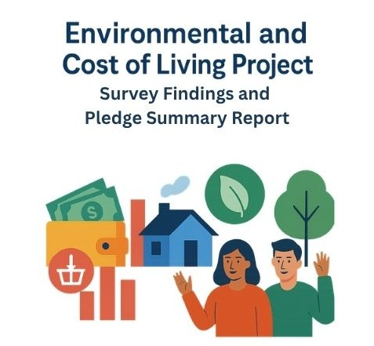

Executive Summary

Background

There are very few community environmental projects in Sandwell, and they are not delivered in a joined-up way. SCIPS and St Albans have been developing a project which will deliver a community approach to support reuse and recycling and alleviate the cost-of-living pressures for residents and families across Sandwell. We are committed to supporting people, services, and communities to get the best value from resources while building a more sustainable future.

The Great Big Green Week – 6th – 14th June 2026

The Climate Coalition Annual Great Big Green Week is a national campaign to involve communities in the environmental initiatives to raise awareness and encourage action. We developed a questionnaire which was designed to gather information about how this agenda effects residents and families on a day-to-day basis. We also produced a pledge sheet encouraged respondents to think about making small changes to their daily lives that will have a positive impact on the environment and potentially save them money.

In addition, we held a number of events throughout the week to promote our Great Big Green Week campaign these included
- St Albans pre school children were involved in a number of environmental activities including litter picking, gardening, bees and flowers and the green police (who checked recycling and energy saving measures throughout their building.
- The Elderberries group who worked with the children to plan sunflowers and made green pledges throughout the week.
- Essex Avenue Community TRA and Lancaster House TRA used their regular coffee morning to discuss environmental issues and make their green pledges.

We received 113 completed surveys and 75 pledge sheets to date. From the 75 pledge sheets we received 853 individual pledges, far more than we expected.

Key Findings
The community survey highlights a population under significant strain from cost-of-living pressures, energy insecurity, and food anxiety, while simultaneously showing strong motivation to engage in environmental action and community involvement. These challenges are interconnected: financial hardship limits sustainable choices, and barriers such as digital exclusion, health conditions, and limited access further reduce participation.
- Survey evidence from Appendix One:
  - Financial hardship: Many households struggle to afford essentials, heat their homes, and maintain food supplies. Few are accessing existing financial support services, indicating unmet need.
  - Environmental concern: Residents care deeply about sustainability but face practical barriers to consistent behaviour change. Knowledge gaps, confidence issues, and affordability constraints hinder action.
  - to participation: Cost, time, health, space, and digital exclusion prevent engagement in both support services and environmental activities.
  - Wellbeing and social connection: A significant minority feel isolated, yet many express a desire to connect, learn, and contribute positively. Activities that combine practical support with social interaction could improve both wellbeing and resilience.
  - Demand for local support: Residents prioritise energy advice, food provision, cost-of-living support, and community-based learning. There is also strong interest in reuse schemes and skill-building, with a preference for accessible, daytime, local delivery.
- Pledge evidence from Appendix Two:
  - The 75 pledge sheets produced 853 individual pledges, averaging 11.4 pledges per person. This shows strong readiness to act, with residents most willing to make practical changes such as:
    - switching off lights and appliances,
    - reducing energy use,
    - buying fewer unnecessary items,
    - reducing food waste,
    - cutting single-use plastics,
    - planting greenery,
    - walking or cycling for short journeys, and
    - sharing ideas with others.

Implications
The findings call for an integrated, place-based approach that addresses both affordability and sustainability. Effective interventions should combine:
- Immediate financial relief (energy and food advice, budgeting support).
- Practical environmental opportunities (repair, reuse, recycling education).
- Inclusive, non-digital, community-based formats that foster social connection.

Case for Funding to Address need
The evidence demonstrates urgent need, high motivation, and clear demand. Investment in the proposed environmental project will:
- Reduce household costs and financial stress.
- Increase environmental action and reduce waste.
- Improve wellbeing and community connection.
- Reach vulnerable and excluded residents.

Conclusion
This is a high-impact, preventative, and community-led opportunity. By addressing barriers and building on residents’ motivation, the project can deliver measurable improvements in financial resilience, environmental sustainability, and social wellbeing.
We would like to take this opportunity to thank everyone who took part in the Great Big Green Week and all those who took the time to complete a survey or pledge form.

Appendix One: Analysis of Survey
Overall Context and Need
The survey findings present a clear picture of a community facing multiple challenges. Cost-of-living pressures, energy insecurity, and food anxiety are widespread, while at the same time residents show a strong interest in environmental action and community involvement.
These issues do not exist in isolation; rather, they reinforce each other. Financial hardship limits people’s ability to act sustainably, while lack of access, confidence, and support further reduces participation.
Together, the results highlight the need for a practical response that addresses both affordability and sustainability change.
Financial Hardship and Basic Needs
The results shows that a significant number of households are struggling to meet basic needs. Many respondents reported difficulty affording essentials, keeping their homes warm, and maintaining a consistent food supply.
Whilst, a majority are not currently accessing financial or budgeting support services, suggesting that need is not only high but also largely unmet.
This indicates a gap between available support and what residents are able or willing to access. The findings suggest that any intervention must prioritise accessible, stigma-free support that delivers immediate financial relief, particularly around energy and food.
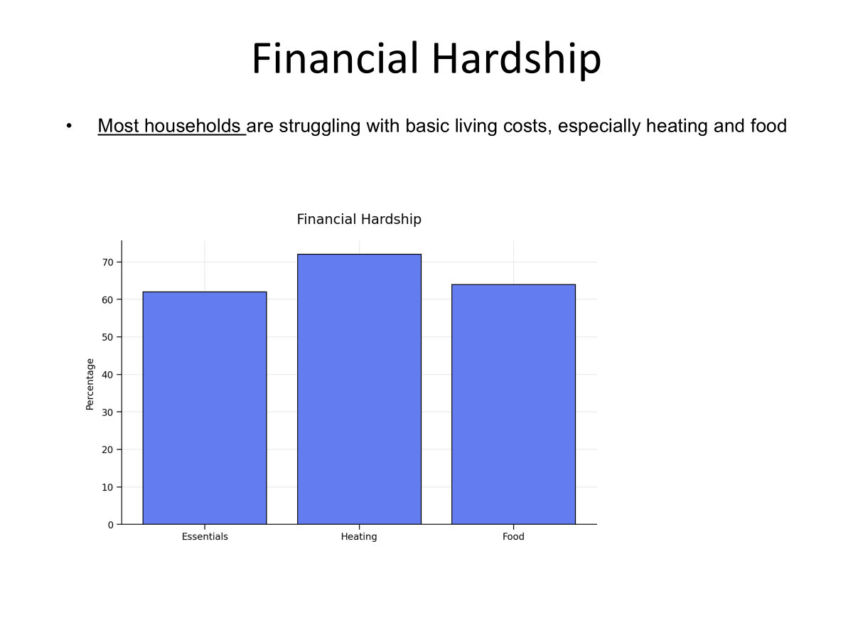

Environmental Concern with Limited Ability to Act
Despite financial pressures, the survey reveals strong levels of concern about environmental issues and a willingness among many residents to take action.
However, this motivation is not translating into consistent behaviour change. While some residents are already engaging in reuse, repair, and second-hand purchasing, others report gaps in knowledge and confidence—particularly around recycling.
This suggests that the issue is not a lack of awareness or interest, but rather a lack of practical, opportunities to act within current constraints.
Supporting residents to take small, affordable steps could unlock significant environmental impact
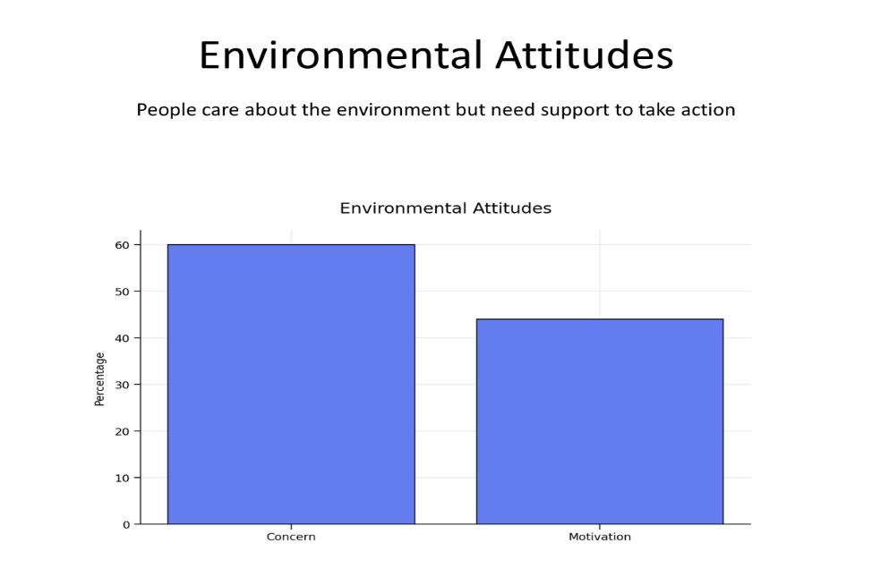
Barriers to Participation
The survey highlights several key barriers that prevent residents from engaging in both environmental activities and wider support services.
Cost is the most significant factor, but time, health conditions, and limited space also play an important role.
In addition, digital exclusion is a notable issue, with many respondents lacking either the confidence or the tools to access online services. These findings demonstrate that current approaches may exclude those who would benefit most. To be effective, future provision must be designed to be inclusive, low-cost, and accessible in non-digital, local formats, ensuring that no one is left behind.
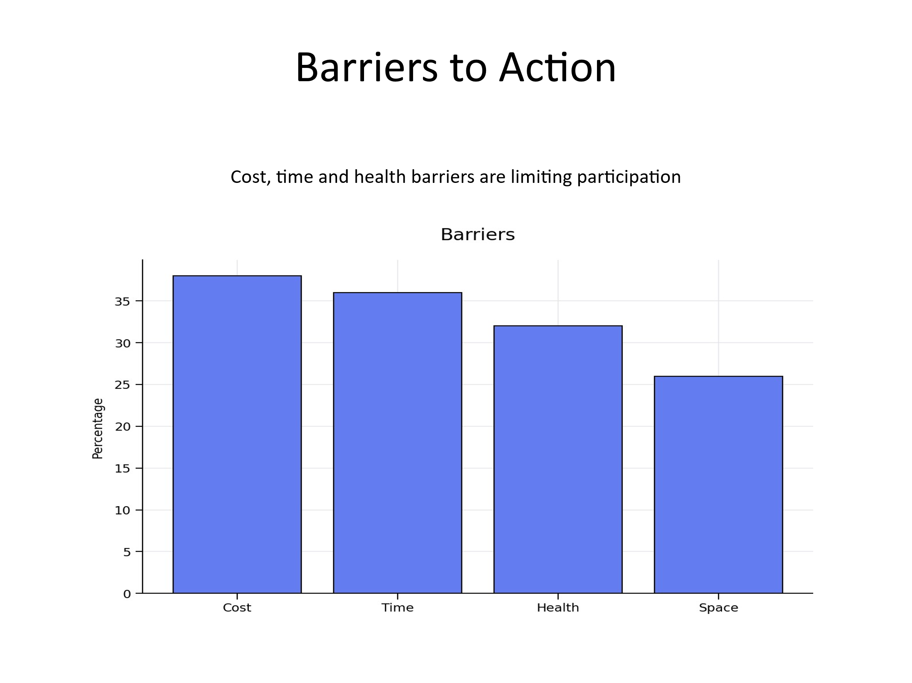
Wellbeing and Social Connection
The results also point to underlying issues around wellbeing and social isolation. While average wellbeing scores are moderate, a significant minority of respondents report feeling disconnected from their community.
At the same time, many express a desire to meet others, learn new skills, and contribute positively. This indicates that there is untapped potential for community engagement, and that activities which combine practical support with social interaction could improving both material circumstances and mental wellbeing.

Strong Demand for Practical, Local Support
Residents clearly identified the types of support they would value most, with demand focused on energy advice, community-based learning, food provision, and cost-of-living support.
Importantly, there is also interest in reuse schemes and skill-building activities. Preferences for daytime sessions and accessible local venues emphasise the need for delivery that fits around people’s lives.
These findings reinforce the importance of place-based, practical interventions that deliver real benefits quickly, rather than abstract or long-term initiatives.

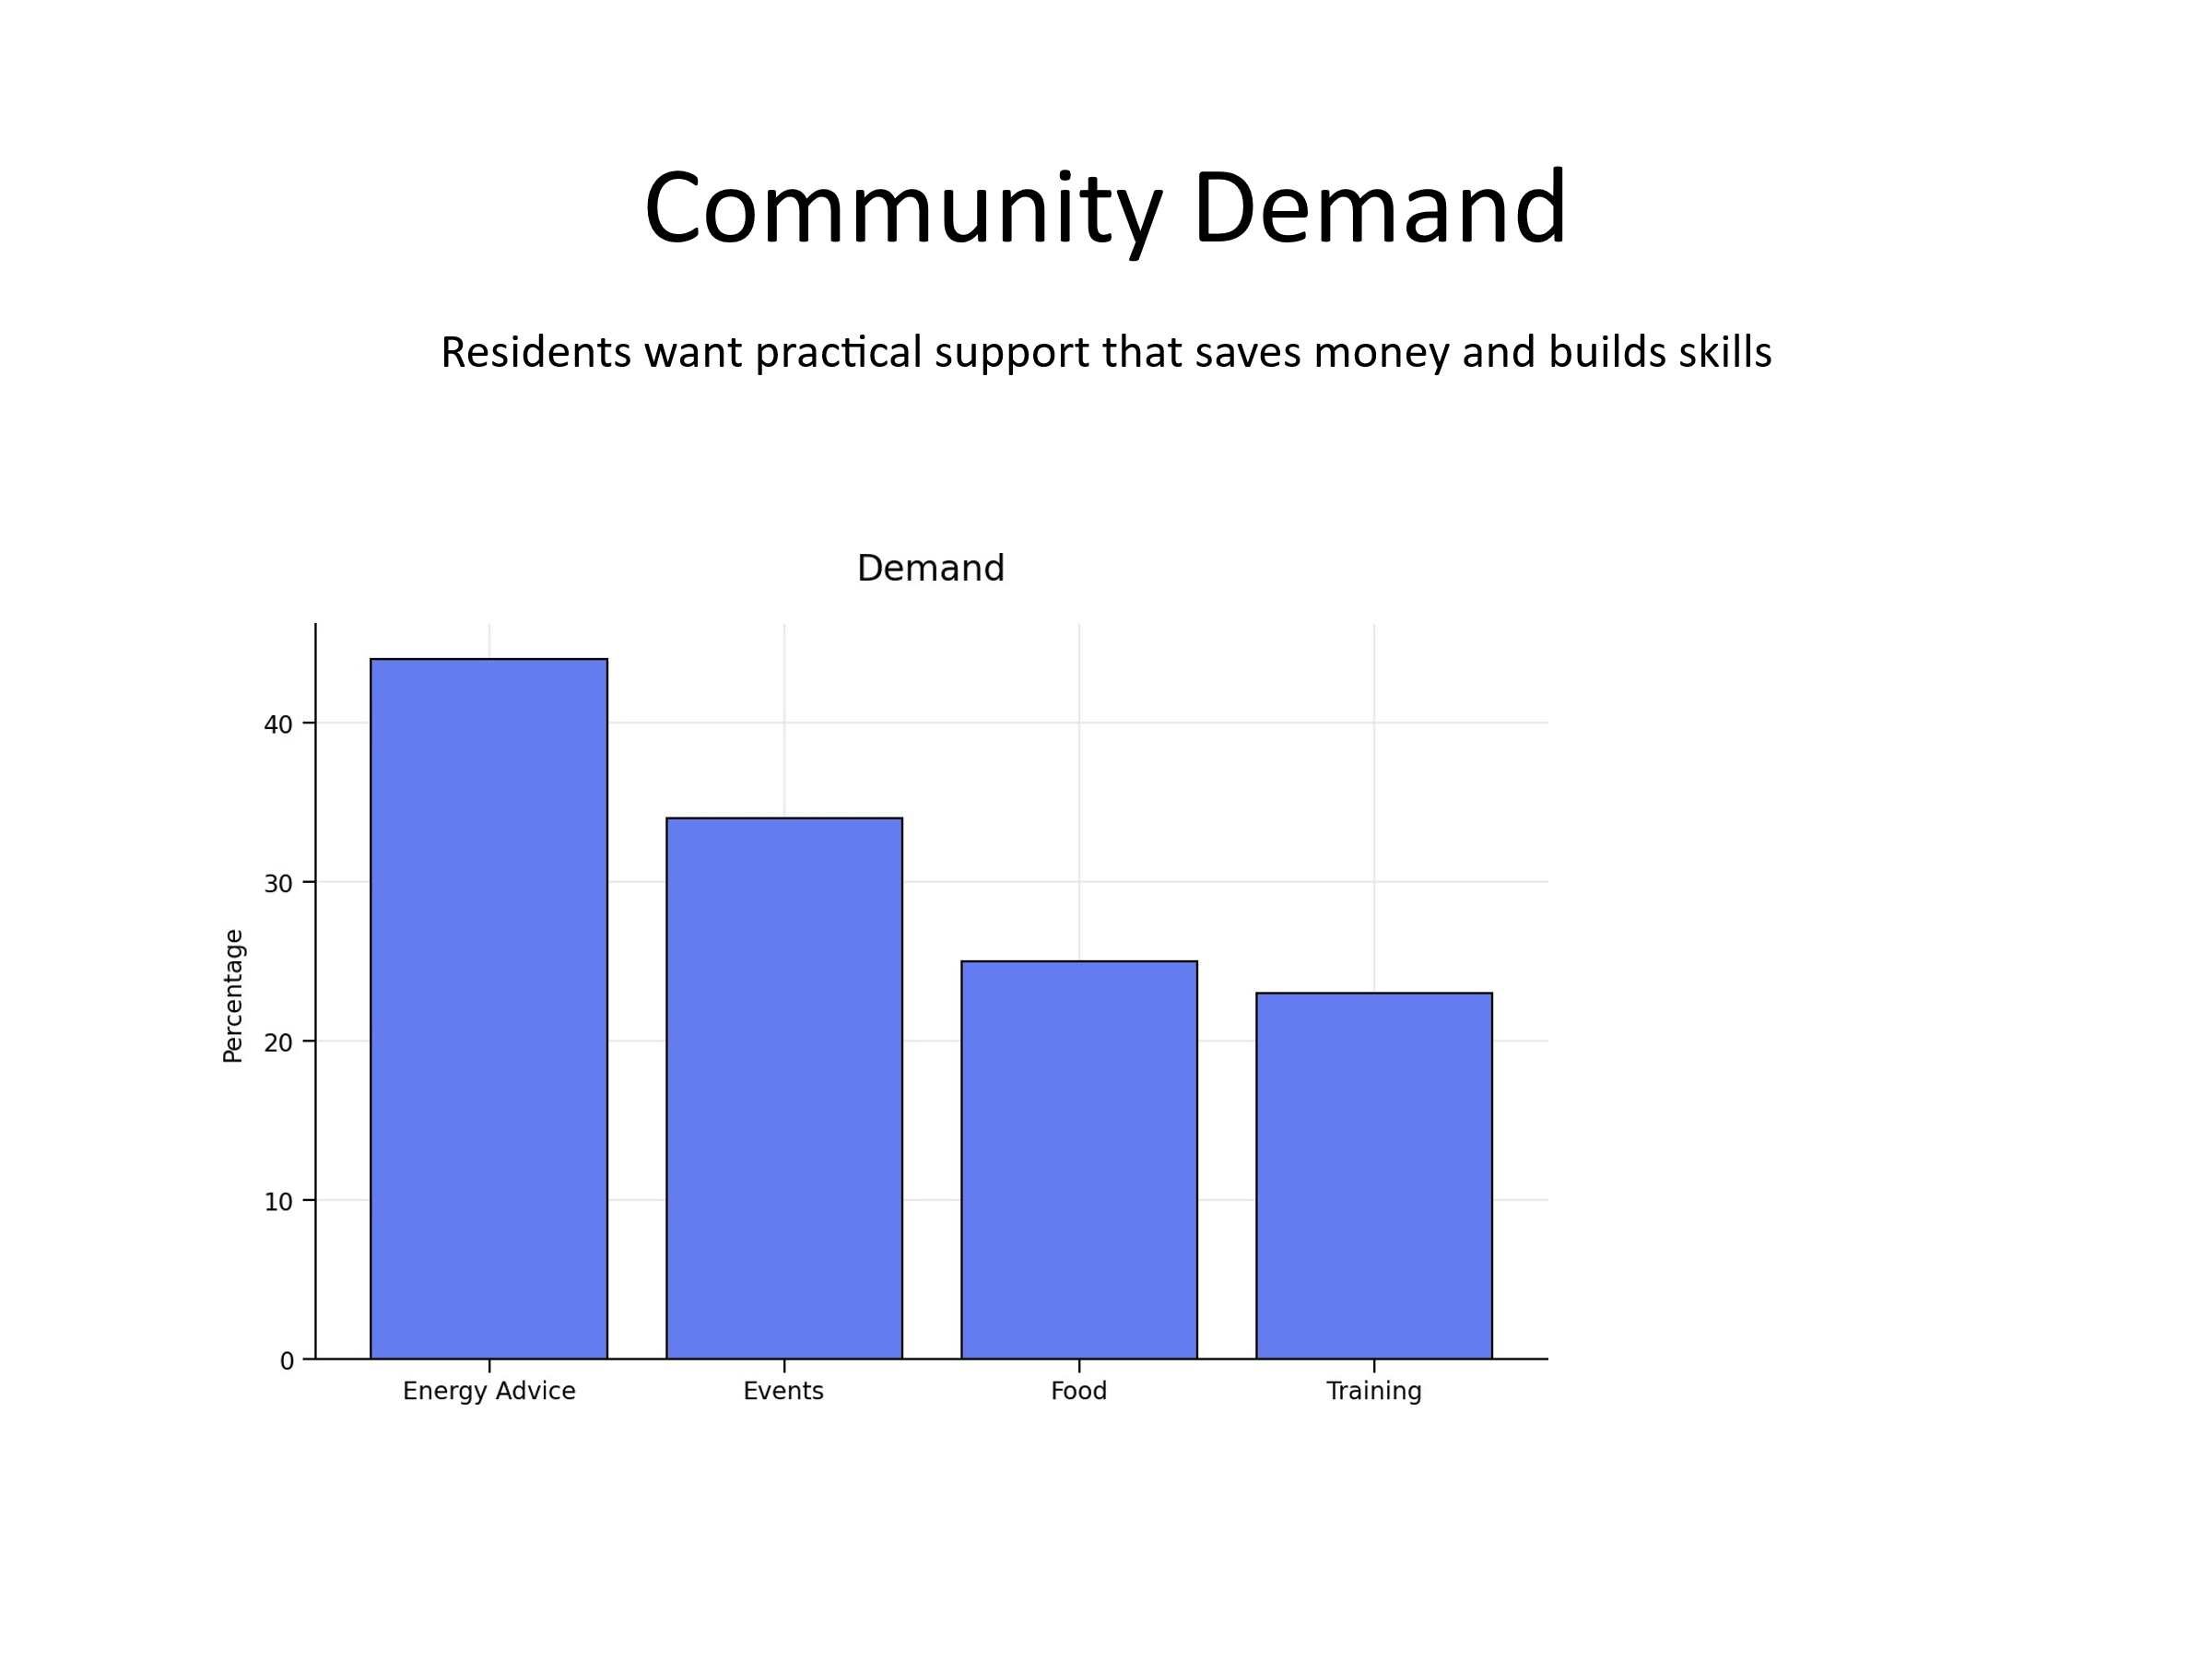
Implications for Project Design
Taken together, the survey results strongly support an integrated approach that addresses both cost-of-living challenges and environmental sustainability.
Residents are motivated and willing to engage, but require support that is affordable, accessible, and relevant to their immediate needs.
This means combining financial support (such as energy and food advice) with opportunities for environmental action (such as repair, reuse, and education), all delivered in a way that promotes inclusion and community connection.

Case for Investment
- Strong evidence of need, high motivation, and clear demand for support.

Investment will:

- Reduce household costs and financial stress
- Increase environmental action and reduce waste
- Improve wellbeing and community connection
- Reach vulnerable and excluded residents
- This is a high-impact, preventative, and community-led opportunity.

Conclusion
The survey clearly demonstrates that there is both urgent need and significant opportunity.
Residents are facing real and immediate pressures, but they are also motivated to improve their circumstances and contribute to positive change.

By addressing the barriers identified and building on existing motivation, the proposed Circle project can deliver meaningful, measurable impact across financial resilience, environmental outcomes, and community wellbeing.

Appendix Two: Community Environmental Pledges Evidence Summary
Appendix One summarises the community pledge evidence gathered during Great Big Green Week in June 2026.
The evidence is based on 75 pledge sheets, containing 853 individual pledges and 25 comments, with an average of 11.4 pledges per respondent.
The results demonstrate a high level of motivation among residents to take practical environmental action.
The strongest pledged actions were everyday behaviours that are low-cost, accessible and repeatable. These included switching off lights and appliances when not in use, reducing overall energy use, buying fewer unnecessary items, reducing food waste, eating less meat, reducing single-use plastics, encouraging friends and family, planting flowers, trees or greenery, walking or cycling for short journeys, and sharing ideas or tips with others.
The pledges identify three main priorities for project delivery: at-home environmental actions, food and shopping choices, and travel change supported through local feasibility and social influence. These findings suggest that a funded project should focus on simple, visible neighbourhood interventions that make residents’ existing green intentions easier to act on.
Recommended activities include home energy advice, appliance-use prompts, shared energy-saving challenges, community fridges, surplus-food links, cooking workshops, repair cafés, swap events, skills sessions, walking groups, cycle confidence activities and short-journey campaigns. These activities align closely with residents’ stated willingness to reduce costs, reduce waste, reuse resources and support one another.
The overall findings support a focused community action programme with clear engagement and outcome measures. The pledge evidence strengthens the case for action because it shows that demand already exists, residents are ready to participate, and the project can deliver environmental outcomes alongside cost-of-living, wellbeing, skills and community capacity benefits.

